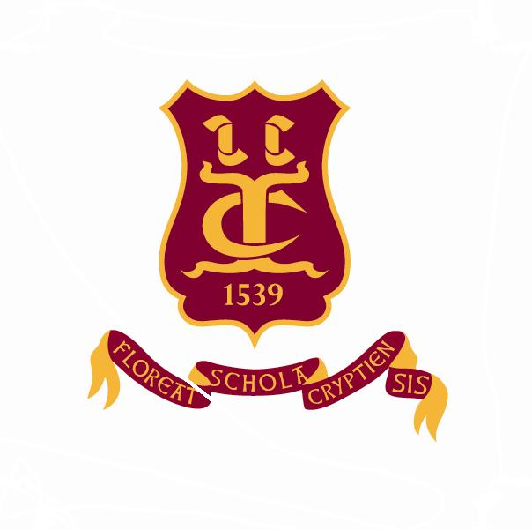
Old Cryptians’ Club
(Founded 1901)

President: Richard Briggs

Founders’ Day - Monday 27th June 2016

Dear Old Cryptians and friends,

I am pleased to inform you of the programme for this special day in the School’s calendar.

10.30 a.m. Golf Competition – The Tony Beard Cup at Rodway GC, Highnam.
Organizer: Bob Timms - 01452 813402 or 07881 401295
(More details on a separate flyer)

7.15 p.m. The Founders’ Day Service in the Cathedral
Guest Preacher: Rev. Jackie Searle

Old Cryptians, partners and friends will be most welcome to attend the Service. For seating purposes, it would be helpful if you would contact Sue Wales (Headmaster’s PA) on 01452 530291

8.15 p.m. The Founders’ Day Supper – Parliament Rooms

In this unique setting, JK’s Restaurant will serve a high-class cold buffet that will include a range of meats, fish, salads and new potatoes. There will be a choice of desserts, a selection of local cheeses with biscuits and tea and coffee. On reception a glass of sparkling wine will be presented to diners.

A number of Crypt students will be on hand to assist guests as required. Orders for drinks will be taken at your tables. The cost of the meal will be £25.

Please see the attached Reservation Form for booking details and contacts

I look forward to welcoming you at the Parliament Rooms.

Yours truly,

Richard Briggs

