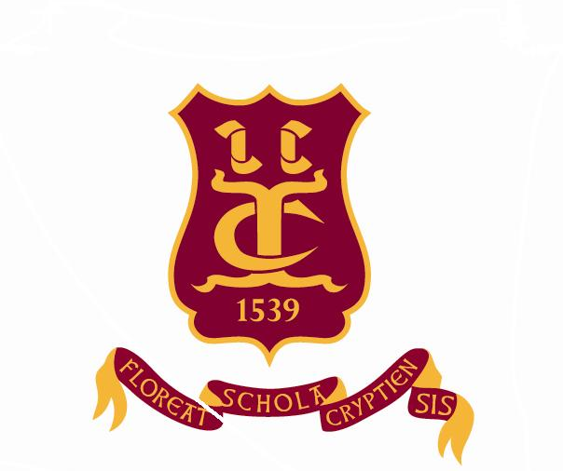
Old Cryptians’ Club
(Founded 1901)

President: Bob Timms

Founders’ Day - Thursday 29th June 2017

Dear Old Cryptians and friends,

I am pleased to inform you of the programme for this special day in the School’s calendar.

10.00 a.m. Golf Competition – The Tony Beard Cup at Rodway GC, Highnam.
Organizer: Eric Stephens - 01452 529000 or ericstephens1939@gmail.com

7.15 p.m. The Founders’ Day Service in Gloucester Cathedral
Guest Preacher: Rev. Bruce Clifford, Vicar of St. George’s Tuffley with St. Margaret’s Whaddon

Old Cryptians, partners and friends will be most welcome to attend the Service and the Supper in the Parliament Rooms. For seating purposes in the Cathedral, it would be helpful if you would contact Sue Wales (Headmaster’s PA) on 01452 530291

8.30 p.m. The Founders’ Day Supper – Parliament Rooms

On arrival in this unique setting a glass of sparkling wine or a soft drink will be served.
The meal will consist of a high-class cold buffet that will include a range of meats, fish, salads and new potatoes. There will be a choice of desserts, a selection of local cheeses with biscuits followed by coffee.

A number of Crypt students will be on hand to assist guests as required. The cost of the meal will be £27. Orders for wine at £10 per bottle will be taken at your tables. Please complete the attached Reservation Form.

I shall look forward to welcoming you at the Parliament Rooms.

Yours sincerely,

Bob Timms

