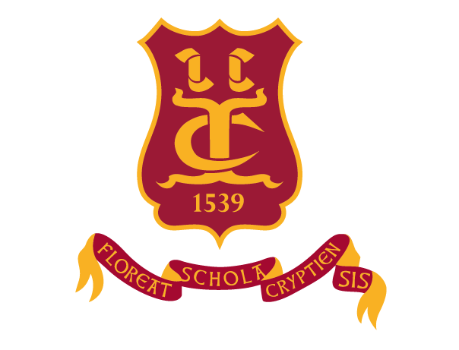

The Crypt School

The Past, The Present, The Future

Friday, 23rd June, 2017
12 noon

All Old Cryptians are warmly invited to the School for a time of reminiscing together, tour the School to see it today, and also look forward to the future of your School.

PROGRAMME

12.15 p.m.
Tour of the School by Sixth Form and Lower School Students, who will be proud to share with you our excellent new facilities, including refurbished Sports Hall and teaching block, Engineering Block, ICT facilities, Sixth Form centre, with displays and demonstration from our F1 in School Team, Robotics, WISE – women in Science and Engineering.

12.45 p.m.
Buffet lunch : an opportunity to meet and chat with fellow Old Cryptians, remember your days here. On display will be many old photographs and the School scrap books – we would be fascinated to see your photographs – particularly if they are named. We have lots of photographs which, unfortunately, aren’t named, and would welcome any help you can give to put names to faces.

1.30 p.m.
Presentations on the future of your School, and our Aim to be the School of choice for many generations to come. We look forward to working with you to secure the future of The Crypt School.

If you are able to come, please email Sue Wales : swales@crypt.gloucs.sch.uk

PS – please pass on this invitation to any Old Cryptian you are in contact with.

Future events for your diary :

- Founders’ Day : Thursday, 29th June

- Annual Speech Day & Prize-giving : Thursday, 14th September

- Remembrance Service : Friday, 10th November

